Canada GP 2025 Recap

Free Practice 1

FP1 saw the return to the first place of Max Verstappen followed by the two Williams drivers (Albon then Sainz). Surprisingly, the McLarens are nowhere to be found despite the team brought a new upgrade to the cars this week. We also saw the crash of Leclerc in this session.

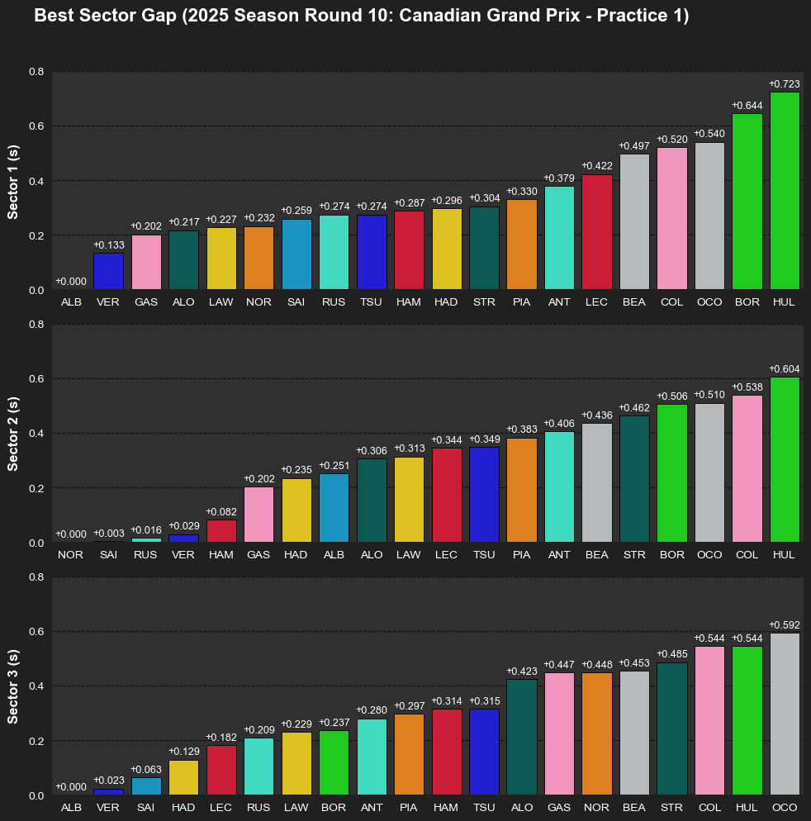

Verstappen did not have the fastest time in any sector; however, he still stayed on top of the list. That was due to the fact that his car was performing consistently throughout every part of the track. Albon may have fastest first and third sector, but in the second sector where it has more corners, the Williams car did not do really well, having a more than two-tenth gaps compared to Norris, who has the fastest second sector time, which is reasonable, given that this year, McLaren handles corners better than any other team.

Free Practice 2

FP2 was mainly for the teams to test the long run pace.

Leclerc did not participate in FP2 as a result of his crash in FP1. Lance Stroll put his car into the barrier and was out of FP2 in his first flying lap.

FP2 saw the rise of Mercedes as Russell and Kimi were first and third fastest drivers on the grid.

Despite having a good top speed car, Yuki seemed to be struggling to transform it into actually result.

Lando clocked in a second fastest lap, showing a redemption effort from McLaren after a underperformed FP1.

Free Practice 3

FP3 saw the return of Leclerc. Top three drivers of this session are Norris, Leclerc and Russell with each driver having a fastest sector time. Mercedes seemed to have the most balance car as Russell was marginally slower than Norris in the second sector and topped the final sector.

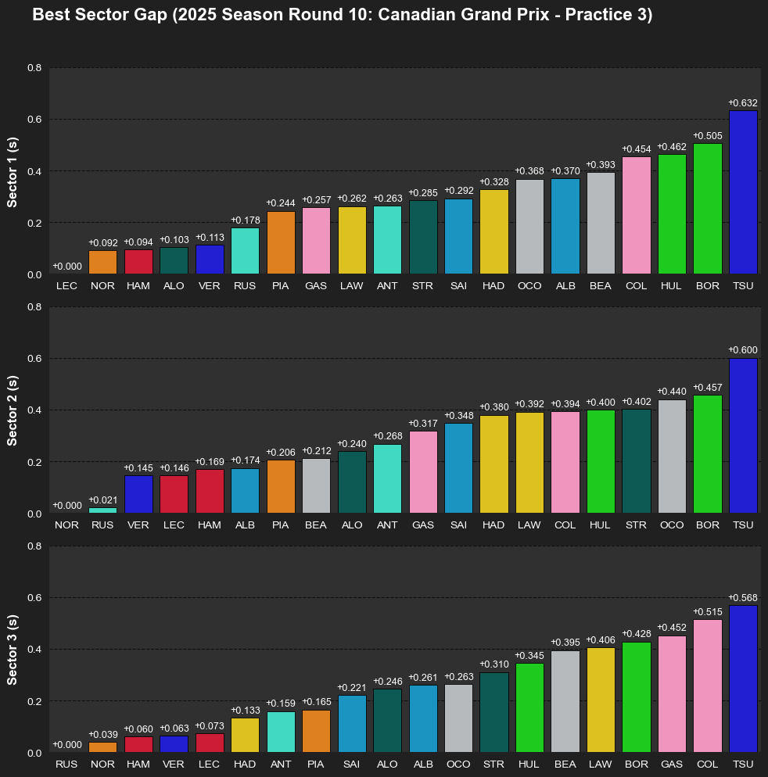

Qualifying

Q1 and Q2 showed us no surprise as they were really consistent with the FPs results. The biggest shock was probably the exit of Sainz in Q1 as Williams was performing really well in practice.

Q3 was exciting as it was unpredictable. At first Lando made a critical mistake, not making the final chicane and therefore abandoned the flying lap attempt, Piastri was on provisional pole with a good lap but immediately got put in P2 as the Redbull of Verstappen took provisional pole. Then, things got mixed up as teams were bringing out the medium compound (C5) to the session with Albon (Williams) and Alonso (Aston Martin) were the first two people to experiment with this tyre. Then, we saw Verstappen and the two Mercedes drivers doing the same thing. The medium tyres proved to be effective right away as Verstappen set an even better time to stay on provisional pole but pole position was snatched by Russell with a phenomenal lap on the new mediums. Antonelli also improved his lap time, got P4 to stay ahead of Hamilton. It was surprising to see McLaren not putting their drivers on the mediums. Despite each McLaren driver having another flying lap attempt, they could not get another front row lock-out since they didn’t have the tyre advantage. This qualifying session once again showed us that with the newest and softest compound C6 on the grid by Pirelli, they are not as effective as the C5 compound (previously the softest compound) when it comes to qualifying session.

VER vs RUS

The telemetry comparison between Russell and Verstappen during their fastest qualifying laps at the 2025 Canadian Grand Prix reveals a clear split in performance dynamics. Verstappen demonstrated superior straight-line efficiency in the first half of the lap, reaching higher top speeds and achieving earlier throttle application out of key traction zones such as Turns 2 and 7. Up to Turn 8, he maintained a time advantage, benefiting from lower drag and efficient corner exits. However, the delta began to shift at Turn 8, where Russell executed a later and more efficient braking phase, carrying greater mid-corner speed and recovering time into the second sector. From that point forward, Russell’s telemetry showed consistently earlier throttle pickups, smoother gear transitions, and higher minimum speeds through Turns 10 and 13. These gains accumulated incrementally and are reflected in the time delta graph, which crosses zero just past Turn 8 and trends in Russell’s favor through to the finish. Despite Verstappen’s stronger opening phase, Russell’s superior cornering efficiency and throttle trace in the latter half secured him pole with a lap that was more balanced and optimized over the full circuit distance.

Main Race

Some noticeable actions in the race include the good light reaction from Russell to keep P1, the overtake from Antonelli to take Piastri position and Albon ran off the chicane to give Hulkenberg 2 positions. Also, the star of the show is Norris, although having some phenomenal effort to climb from P7 to P4 but the wrong judgment on lap 67 took him to the wall and deleted all the efforts. Once again, in the fastest car, Norris continues to show a lot of mistakes. This makes people question whether or not he can cope under pressure with his teammate on top of the Driver Championship and Verstappen right behind him. The main race has a driver parade vibe, although not as bad as Monaco or Imola, since every driver wanted to be look after their tyres as much as possible. And once again, the compound choice by Pirelli is the culprit behind these parade races. The choice of one compound softer (C4-C5-C6) doesn’t make sense with the Montreal heat. This led to drivers cannot punish their tyres too hard, unless they want to risk with a 3-stop strategy. Most drivers starting on Mediums has to end their first stint around lap 15 or earlier, which put them at a disadvantage compared to people who started with Hards, since they must commit to a 2-stop strategy. From the graph, we can see that degradation of the Mediums happened around the 6-7th lap (which is terrible). Pirelli said that the emergent of the new compound is to make races to be more competitive but with it proven to be bad both during qualifying and main race, it is more likely to leave strategic mark rather than more actions on track. On the other hand, drivers starting on Hards were far more comfortable, with a number of drivers able to pull off a one-stop strategy.

Race pace analysis from the Canadian Grand Prix revealed a standout performance from Mercedes, who not only delivered the fastest median lap times but also maintained exceptional consistency throughout the race. McLaren was a close second, showing similarly strong long-run pace and minimal variation, suggesting effective tire management and a well-balanced setup. Ferrari and Red Bull were also competitive on raw pace, but both suffered from wider lap time spreads—an indication of possible tire degradation or inconsistent stint performance. Aston Martin settled into a midfield position with average pace and moderate consistency, while Haas, despite being among the slower teams, managed to extract a stable and predictable performance across stints. At the other end of the spectrum, Sauber, Alpine, Williams, and Racing Bulls all struggled with both outright pace and consistency. Their distributions revealed higher variability and numerous outliers, pointing to setup instability or tire management issues that compromised their ability to compete over a race distance.

Finally, this is a position change plot to summarize the race.

